Recognizing the string of a determined DFA

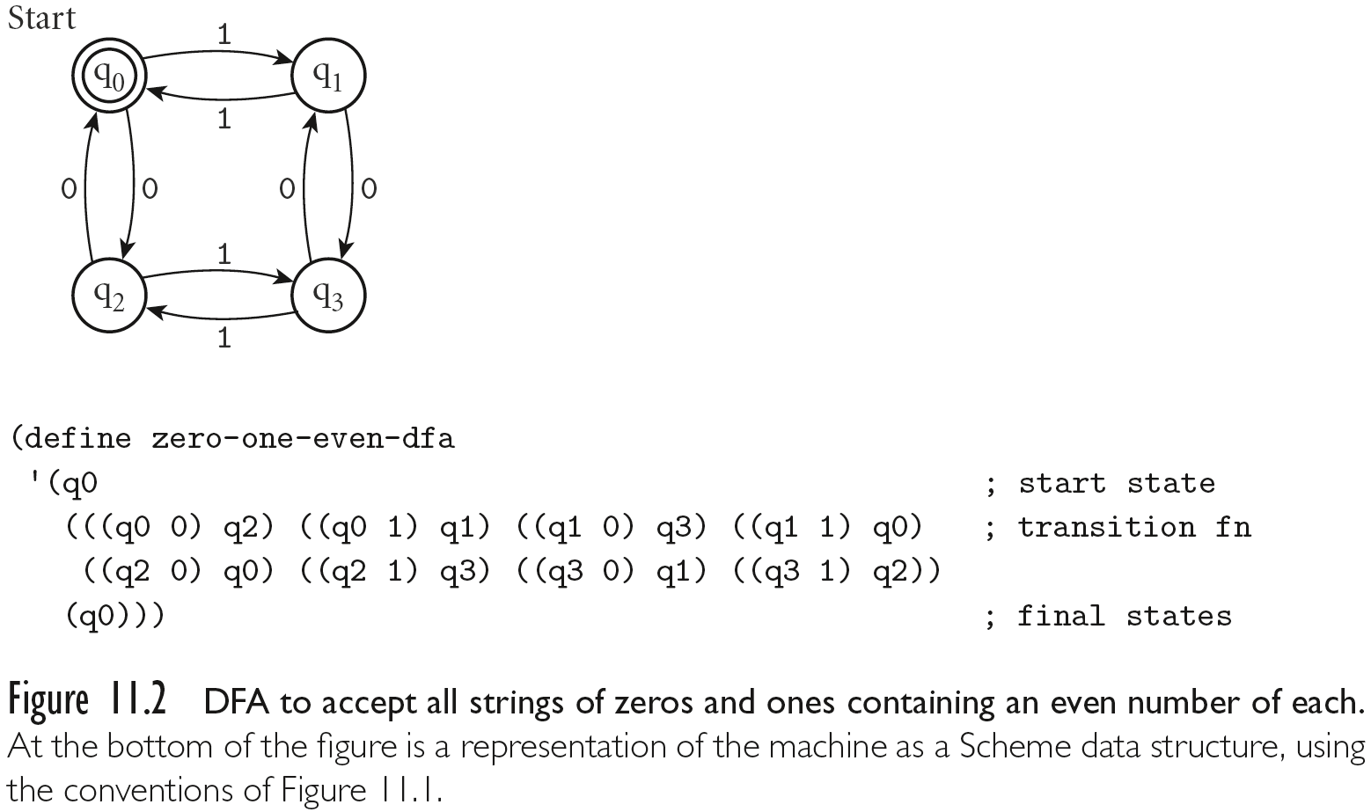

This DFA has the starting state q0; only one final state q0; and then the transitions.

Notice how the DFA is defined as a list that the first element is the start state, second element is a list of transitions, third element is the list of final states.

Notice that the above DFA recognize only string of even numbers of 0’s and/ even number of 1’s

The empty string is recognized too, because, the start state is also a final state.

Here it is first draft of a racket program

#lang racket

;;;The final state is "q0"

(define (is-final-state? state) (if (equal? state "q0") #t #f))

;;;transitions

(define (q0-state substring)

(cond

((equal? substring "1") "q1" )

((equal? substring "0") "q2")

(else "not in the alphabet")))

;

(define (q1-state substring)

(cond

((equal? substring "1") "q0" )

((equal? substring "0") "q3")

(else "not in the alphabet")))

;

(define (q2-state substring)

(cond

((equal? substring "0") "q0" )

((equal? substring "1") "q3")

(else "not in the alphabet")))

;

(define (q3-state substring)

(cond

((equal? substring "0") "q1" )

((equal? substring "1") "q2")

(else "not in the alphabet")))

;;; next state

(define (next-state s str ) (cond ((equal? "q0" s) (q0-state str))

((equal? "q1" s) (q1-state str))

((equal? "q2" s) (q2-state str))

((equal? "q3" s) (q3-state str))

(else "error") ))

;;; parse the string

(define (parse str) (if (equal? str "") "it is in the language" (is-in-the-language? "q0" str)))

(define (is-in-the-language? state str)

(cond

((and (= (string-length str) 1) (is-final-state? (next-state state str))) "it is in the language")

((and (= (string-length str) 1) (not (is-final-state? (next-state state str)))) "no in the language")

(else (is-in-the-language? (next-state state (substring str 0 1)) (substring str 1)))

))

3 points to program the following DFA

FSA for 0*1 ( (1 0* 1)* | (0 1* 0)